


Computer Communications 25 (2002) 1094±1102

www.elsevier.com/locate/comcom

Analytical modeling of primary and secondary load as induced by video
applications using UDP/IP
B.E. Wol®nger*,M. Zaddach,K.D. Heidtmann,G. Bai¹
Department of Computer Science, Telecommunications and Computer Networks Division (TKRN), Hamburg University,
Vogt-KoИlln-Straыe 30, D-22527 Hamburg, Germany
Received 1 August 2001; revised 30 October 2001; accepted 28 November 2001

Abstract
A particular challenge,when trying to analyze and predict the behavior of subnetworks of the global Internet,refers to the task of
elaborating a suf®ciently realistic workload characterization. In particular,it is necessary to specify (work)load at different system interfaces.
This paper presents a generalized proceeding for load modeling,which can be used to formally describe sequences of (communication)
requests at well-de®ned interfaces within a network. At ®rst,the basic proceeding is applied by way of example to the modeling of primary
load,i.e. load at an interface close to end-users,whereby we focus on video sources. We then tackle the challenging problem of characteriz-
ing secondary load,i.e. load as it is occurring at a lower layer interface within a protocol/service hierarchy,and for this purpose,we suggest a
new approach for analytical modeling of load transformations as they are typical for communication networks. The broad applicability and
the high validity of our approach to model load transformations is exempli®ed by means of a comprehensive case study assuming video
sources and considering some load transformation corresponding to the impact within a RTP/UDP/IP protocol hierarchy. q 2002 Elsevier
Science B.V. All rights reserved.
Keywords: Workload characterization; Load transformation; Traf®c engineering; Internet; Video communication

1. Workload characterization and load modeling for
computer networks
When modeling service-systems,such as computers,
communication networks,database systems,etc. it is a
common practice to clearly separate the requests to be
processed/served from the service-system properly which
serves the requests. The set of requests to be served over
time is denoted as load or workload of the service-system.
If we apply this view to computer systems the requests to
be served may correspond,e.g. to user programs to be
executed,and in database systems the transactions to be
processed may represent the load. In computer networks
[17] ®les,e-mails,audio or video streams,WWW pages,
etc. could represent the load if we consider an application-
oriented interface,whereas at an interface to a packet-
switched network the packets to be transmitted would
constitute the load which is handed over to the network. It
is well known that a suf®ciently realistic load characteriza-
tion,in most cases,is an indispensable prerequisite in order
* Corresponding author.
E-mail address: wol®nger@informatik.uni-hamburg.de (B.E. Wol®nger).
1 Presently with Department of Computer Science,University of Calgary.

to obtain valid results when predicting the expected system
behavior under a given load (e.g. by means of modeling or
measurement studies) [5].
In the case of computer networks analyses,realistic load
characterization is required,e.g. when applying analytical
models or when executing simulation experiments. More-
over,load characterization is needed for the construction of
arti®cial load generators,which e.g. may generate some
synthetical load for an existing communication network.
Using such load generators network behavior,under various
load conditions,can then be investigated by means of
measurements.
As we will explain in Section 2 in some more detail,load
characterization on one hand has to specify the single
requests which in their totality represent the overall load
and on the other hand,it has to specify the stream of requests
(arrival process) at a well-de®ned interface of the service-
system considered. Depending on the desired range of use of
load characterization very different degrees of freedom may
exist for this characterization.
In this paper as a revised version of Ref. [19] we want to
tackle the dif®cult problem of load characterization for the
Internet. In particular,our contribution will introduce a
Їexible method for characterizing load at very different

0140-3664/02/$ - see front matter q 2002 Elsevier Science B.V. All rights reserved.
PII: S0140-3664(02)00023-3

B.E. Wol®nger et al. / Computer Communications 25 (2002) 1094±1102

1095

interfaces within a UDP/IP-based protocol hierarchy. Our
new method of load characterization will be based on the
analytical modeling of load transformations. To demon-
strate its practical relevance,we will apply the method by
way of example.
Section 2 summarizes some of the features and properties
of the Internet which make characterization of load for this
network and its users extremely dif®cult. Moreover,we
indicate the state-of-the-art in load measurements and load
modeling of the Internet. We apply a generalized proceed-
ing for load modeling as suggested in Ref. [17] during a ®rst
case study (Section 3) to characterize load as it could occur
at an application-oriented interface within an Internet host
computer. In the study,by way of example,we will model
video streams starting from detailed load measurements and
assuming standards for video encoding,such as H.261/
H.263 (for MPEG cf. Refs. [3,4,18±21]).
Our view is that load at an application-oriented interface,
which we call primary load (PL),is transformed by parts of
the communication system into a different load,called
secondary load (SL),which we can observe at a lower
layer interface within the given protocol hierarchy. The
topic of load transformation and an innovative method for
its analytical modeling will be discussed in the context of
Internet (cf. Section 4). In Section 5,our second case study
will illustrate our new approach to model load transforma-
tion processes. We will demonstrate these transformations
for the RTP/UDP/IP stack because of its importance for
real-time applications. Thus,we will be able to characterize
in a highly realistic manner the SL (IP traf®c at an LLC
interface) as it would be induced by a set of video traf®c
sources corresponding to the PL,e.g. within a video server.
Our load transformation approach will be successfully
validated in Section 6 by comparing measured SL (as
observed in an Internet subsystem) with SL as it is predicted
after transforming a given PL in the modeling domain.
2. Special aspects of modeling Internet load
In this paper,we are going to use the following de®nition
of load, cf. Refs. [3,11,14,17].
The (offered) load or workload L L E; S; IF; T denotes
the total sequence of requests which is offered by an
environment E to a service-system S via a well-de®ned
interface IF during the time-interval T. We call L the load
generated by E for S at IF during T. Let us shortly discuss the
strong dependencies of L on E, S,IF and T for the case of a
computer network:
І E: all the requests to be served by S are created within the
environment which,in particular,comprises the set of
(human) network users as well as the (distributed)
applications.
І S: as the service-system is responsible for serving the
requests originated by E,the characterization of requests
has to specify among others,the resource requirements of
each request during its processing/service by S.
І IF: the interface chosen is extremely important as it
reЇects the decomposition of the computer network and
its users into E and S; IF also directly determines the type
of requests which can be part of the workload and,more-
over,it limits the set of possible sequences of requests.
І T: evidently,the load observed in an existing network is
highly dependent on the choice of T.
In the following,we want to focus on load characteriza-
tion for the Internet. In Ref. [19],e.g. we debated the
question why load characterization for the Internet is so
much more dif®cult than characterizing load in networks
like corporate networks or conventional LANs.
As a direct consequence of our de®nition of load,load
characterization always assumes a well-de®ned interface.
Unfortunately this is quite often not taken into account in
existing publications. In the context of Internet we could,in
particular,choose the following interfaces for load charac-
terization: an application-oriented interface (e.g. interface to
services/protocols such as FTP,Telnet,HTTP,SMTP,ј)
[2,8,12]; interface to the transport services, based on TCP or
UDP,within the endsystems [22]; the packet interface to IP;
or the LLC interface,e.g. in an Ethernet-based Intranet.
For most of the Internet interfaces mentioned,a large
number of publications exist presenting load measurements
for these interfaces. In particular,load measurements for
application-oriented interfaces in the Internet have been
presented in Refs. [2,22], measurements for the transport
layer interface cf. Ref. [15] covering TCP and [22] covering
UDP. Load measurements referring to IP interface have
been summarized in Refs. [6,7,10].
Load measurements for speci®c interfaces in communi-
cation networks can be used to look for stochastic processes
which are able to reЇect,with suf®ciently good accuracy,
the main characteristics of the arrival process observed. In
order to supplement the existing approaches to approxi-
mately measured Internet load by means of stochastic
processes,we argue for a more general proceeding which
is not restricted to mathematical modeling but allows us
some detailed load characterization and load modeling for
simulation models and arti®cial load generators of IP-based
networks,too.
Our approach to load characterization and modeling will
be presented in detail in the following sections and it will be
applied in the context of the Internet. The approach
comprises a generalized proceeding for load modeling
directly based on load measurements. We suggest tackling
the problem of load modeling for communication networks
starting with modeling of the PL,as it exists at an
application-oriented interface. We start with modeling the
PL because this allows us a straightforward modeling of SL
in a rather Їexible way (e.g. for various choices of SL inter-
faces). Quite often PL can be observed in a relatively simple
and direct manner and load at such application-oriented

1096

B.E. Wol®nger et al. / Computer Communications 25 (2002) 1094±1102

interfaces typically is created quite independently of the
communication network's state. Moreover,a complex PL
can be conceived as an (mutually independent) overlay of
elementary single sources of PL (e.g. single MPEG source
in video communications,single ®le transfer using FTP,
transmission of a sequence of PCM samples resulting of a
single voice source,etc). Once we have solved the problem
of characterizing the single sources of PL (for various types
of sources,cf. examples of source models in the context of
ATM networks as introduced in Ref. [16]),by means of
overlaying single sources,we can produce mixes of
complex PL. Thereafter,we can apply our approach for
load transformation (cf. Section 4),in order to obtain a
realistic characterization of the SL which exists at some
arbitrarily chosen lower layer interface and which is induced
by the complex mix of PL.
For this innovative approach to characterize SL,of
course,we have to assume some suf®ciently detailed knowl-
edge regarding the process of load transformation as it
occurs in the communication network and,moreover,that
the load transformation is not too strongly dependent on the
network's state. One of the main advantages of our approach
to SL characterization is that it is not necessary to measure
at the SL interface. Therefore,this method of load charac-
terization can also be applied during the design of an inno-
vative communication network under the assumption that
the kind of load transformation in the newly designed
network is known suf®ciently precisely and that PL will
be created in the future network in the same or in a similar
way as in the present network. Another important advantage
is that it is not necessary to create a possibly very complex
mix of PL in an existing network; it is suf®cient to consider
this mix of PL in the modeling domain.
Our subsequent modeling of primary traf®c loads for the
Internet will be based on the generalized procedure
proposed in Refs. [3,11]. The main purpose of this pro-
cedure is to present a uni®ed description technique which
allows us to formulate models of load (mainly for simula-
tion experiments) for different degrees of detail in modeling
and for various kinds of system interfaces. In particular,we
want to cover load,which reЇects requirement of commu-
nication resources.
For a presentation of our generalized load modeling
method,we refer the reader to Ref. [17]. Quite comprehen-
sive experiences in applying the modeling method have
been reported by Bai [3]. A load description language
based on extended ®nite automata has been elaborated by
Kim [11] and a load speci®cation technique based on
extended Petri nets,is presented in Ref. [14].
3. Modeling of Internet traf®c at an interface of primary
load in video communications
In video communications via packet-switched networks,
e.g. the following two classes of applications can be
distinguished,video conferences and video-on-demand
(VoD) services. While both types of applications do have
different constraints referring to quality and real-time
context,there are several similarities. In video conferen-
cing,the video sequence as collected by a camera at discrete
time instants leads to an isochronous stream of data units
(uncompressed video frames) over time. The video frames
are passed to a video encoder for compression at a frequency
of v frames=s: To achieve encoding in real-time the encoder
has to execute compression of one frame in less than 1=v s:
The video frames are passed to a transport system for RTP-
based transmission again as an isochronous stream. The
delay j (between provisioning of the uncompressed and
transfer of the compressed frame) of the transport system
is strongly determined by the speed of the video encoder.
The class of VoD applications has only to transmit already
encoded,i.e. compressed streams. In this case,the delay j
could be signi®cantly higher,but in order to realize high
QoS,the time instances related to frame transmissions at
sender and receiver should be synchronized as well.
In the following,we want to model PL as it is generated in
video communications at an interface close to the video
source. In particular,we want to observe the compressed
video stream at the interface (IF_{P}) between application-
oriented services and the transport system. As we are
going to strictly base load modeling on load measurements,
we have to collect measurements at IF_{P}. The arrival process
of the video streams at IF_{P}is very regular because of its
isochronous nature. As is usual in modeling video load [13],
in the following,we assume that length of frames is the only
attribute of interest for the requests observed at IF_{P}. There-
fore,we have to measure the length x_{i}(in bytes) of the ith
video frame being passed via IF_{P}at time t_{i}t₀1 i=v s; if
t₀denotes the start of the observation interval. The trace of
frame lengths X {x_{i}ui 1; 2; ј; n} describes the load and
leads to the empirical distribution function H s
1=n n_{i}1 1{x_{i}#s} s ; s [ R; where 1_{V}denotes the indicator
function for the set V # R:
We carried out comprehensive load measurements [3,21]
based on well-established standards for video encoding,
such as H.261,H.263 and MPEG,in order to obtain results
of general interest. The series of experiments referred to in
this section cover 52 different video sequences,varying the
quantization levels from 1 to 18. We exemplify the results
by discussing one series of experiments in some more detail,
in particular choosing the widespread reference sequence
Claire. The sequences,we have analyzed,lead to the
hypothesis that lengths of frames can be closely
approximated by a normal distribution as illustrated,e.g.
in Fig. 1 as well as in our publications [19±21]. The empiri-
cal mean a^ 1=n n_{i}1 x_{i}and estimated variance s^ 2
1=n n_{i}1 x_{i}2 a^ 2 were determined by the maximum like-
lihood method.
In order to quantitatively judge the accuracy of the maxi-
mum likelihood estimates,by means of a x²-test,we tested
the empirical distribution for normal distribution according

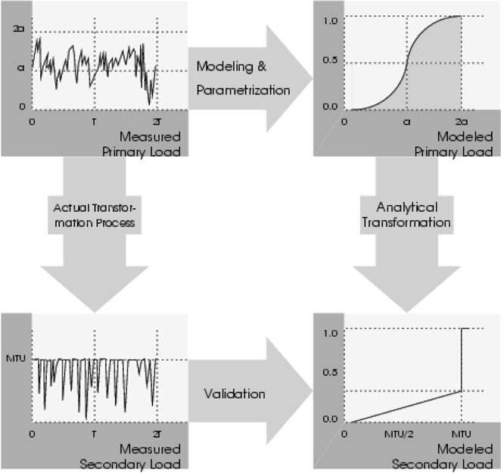
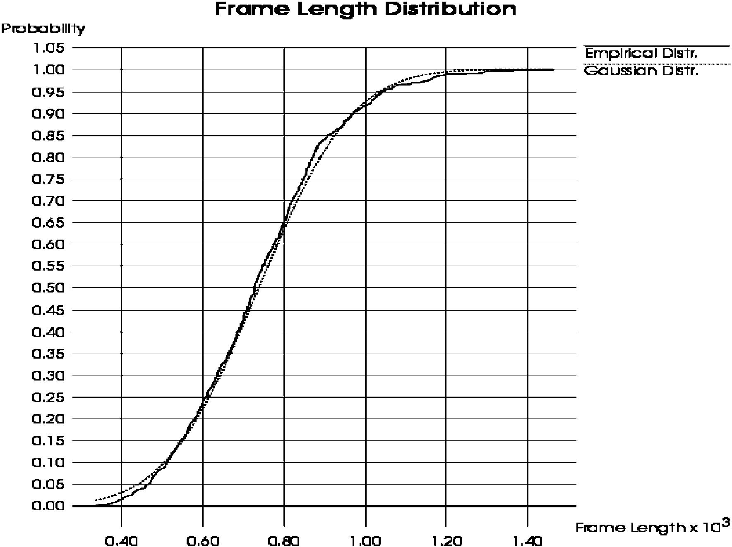
B.E. Wol®nger et al. / Computer Communications 25 (2002) 1094±1102

Fig. 1. Frame length distributions of the sequence Claire,quantization level
4,H.261 encoding.
to N ^; s^ 2; x F x 2 ^ =s^ and,in all cases,the results
suggested to accept the hypothesis of normal distribution
(details,cf. Refs. [18,20]). Thus,it seems acceptable to
characterize the marginal distribution function of video Fig. 2. Analytical modeling of load transformations.
frame lengths by approximate normal distributions. An

1097

important advantage of this approach results from the fact
that the normal distribution is determined by only two
parameters and it allows a straightforward derivation of
quantiles and other statistical quantities.
Because of predictive encoding the frame length generat-
ing process could be strongly autocorrelated. We have
carried out comprehensive measurements of the auto-
correlation function r^ t (coef®cient of correlation with
lag t) and we have observed [18±20] that the autocorrela-
tion structure is based on long term dependencies,that it
collapses,if these dependencies are eliminated,referring to
short term measurements.
Our restriction to homogeneous video sequences and the
strict separation between I- and P-frames evidently elimi-
nates self-similar structures [20].

4. A new approach to model load transformations
In Section 3,by way of example,we have investigated PL
as generated by video encoders. We can interpret the
processing of data units within protocol layers as a process
of transformation effective on the PL and producing the so-
called SL. Let us denote components which transform load
as (load) transformers. Load transformers change the prop-
erties of the load,e.g. in such a way that,on one hand,data
units corresponding to the SL may become larger or smaller
than those of the PL or that,on the other hand,the inter-
arrival times of requests may be changed.
In communication systems a PL at some interface IF_{P}
within the protocol hierarchy induces a SL at some lower
layer interface IF_{S}. Characterization of SL in many cases is
as important as or even more important than characteriza-
tion of PL. In characterizing SL,as it would be induced by
some given PL,the following two approaches can be distin-
guished: direct measurement of the (real) load at interface
IF_{S}in an existing communication system or modeling of SL.
In case of the ®rst approach,we would have to generate
the PL of interest in the real network and measure the SL
which arrives at IF_{S}after having passed the real transfor-
mation process (e.g. the protocol processing). This
approach is not feasible if the interface IF_{S}is not accessible
for measurements in an existing network or during design
or early development of a new communication system,
when IF_{S}would not yet be implemented. Moreover,it
could be necessary to investigate a SL as it would be
induced by a very special mix of single sources on the
level of PL and it could be impossible to generate this
mix in the existing network.
In the second approach based on modeling,the inЇuence
of parts of a communication system on a given PL is
reЇected by a model. Here,the real transformation process
is replaced by a so-called arti®cial transformer (transforma-
tion in the modeling domain). The purpose of an arti®cial
transformer is to convert the attributes (and their values) of
PL into those of SL as well as to transform the arrival
process of PL requests into the one for SL requests. If the
arti®cial transformer used is a suf®ciently valid model of
reality,we can obtain a realistic prognosis of SL to be
expected.
Load characterization has to cover the speci®cation of
the arrival process of requests as well as the speci®cation
of the values of request attributes. The characterization can
be deterministic if we use,e.g. some trace or it may be
probabilistic if we use,e.g. some distribution to reЇect the
interarrival times and the attribute values of the requests
generated over time. This implies the following levels of
abstractions for the load: the actual load,its description as a

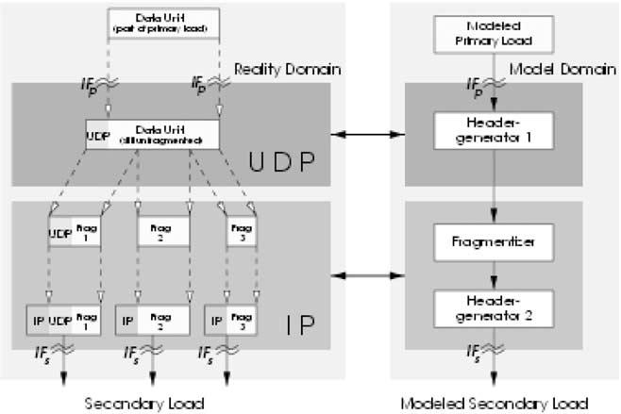
1098

B.E. Wol®nger et al. / Computer Communications 25 (2002) 1094±1102

trace,or its probabilistic characterization by means of
distributions.
Some measured load can be approximated by a distribu-
tion (e.g. to characterize lengths of data units) which may be
directly used as a model of PL by an arti®cial transformer.
The arti®cial transformer may then reЇect the transforma-
tion process just by changing (recalculating) the given
distribution into a new one to approximate the induced SL
(cf. Section 5,for example). The validity of the predictions
of the arti®cial transformer can be determined by means
of comparisons with measured SL (cf. Fig. 2 for some
graphical illustration of the proceeding).
In an earlier work,as opposed to this paper,we already
investigated load transformation by means of simulation
[3,4,11].
In this contribution,we want to advocate for analytical
load transformation. As is common in modeling,in the
special case of modeling load transformations too,analyti-
cal modeling offers the important advantages of only minor
programming and calculation effort in evaluating the
required formulas as well as leading to more comprehensive
possibilities of model evaluations and result interpretations.
Transformation processes reЇecting the behavior of
complete protocol hierarchies as they exist in nowadays
networks are very complex as a consequence of all the
various (layered) services they have to support. So,there
does not seem to exist any hope that a suf®ciently realistic
analytical modeling of load transformation should be feasi-
ble. To solve this problem,nevertheless,we suggest to map
the complete process of load transformation onto a sequence
of elementary load transformations which take place one
after the other and thus to achieve analytically tractable
transformations.
Moreover,we distinguish two classes of elementary
transformations. A ®rst class of elementary load transforma-
tions only allows the modi®cation of the interarrival times
between requests. Examples of such transformations are
algorithms for smoothing traf®c such as Leaky Bucket-
Algorithms. A second class of elementary transformations
modi®es request types and attributes but keeps constant the
request interarrival times. To give an example for a trans-
formation of the second class,generation of packet headers
typically does not signi®cantly change the packet inter-
arrival times whereas it modi®es the attribute packet length.
Astonishingly,a large variety of transformations of the
second class which are relevant in real networks are still
analytically tractable in a very realistic way as we could
prove in Ref. [20],namely transformations such as frag-
mentations of protocol data units,generation of CRC check-
sums,bit stuf®ng,some kinds of compression algorithms,
etc.
And even transformations which at the same time modify
interarrival times between requests and attributes may still
be accessible by analytical models to reЇect load transfor-
mations,if we conceptually separate transformation of
timing from transformation of request attributes.

Fig. 3. Modeling SL using load transformers.

5. Modeling of IP traf®c at an LLC-interface as an
example of secondaryload characterization in a video
server
The general concept of load transformation (e.g. by proto-
col layers) as introduced in Section 4 will now be exempli-
®ed in looking at load transformations being typical for the
Internet. As we want to make use of our results for PL
modeling as presented in Section 3,in the following we
assume video communication directly based on UDP
(RTP) and IP protocols (cf. Fig. 3).
The interface IF_{P}which we choose to observe PL,as it is
generated by the video sources,corresponds to the UDP
transport service-access-point (TSAP). The interface IF_{S}
chosen by us for SL observation and modeling corresponds
to the interface between IP layer and the network adapter
(i.e. Ethernet adapter in our case). The interface IF_{S}chosen
is still suf®ciently of high level in order to make results of
load modeling not too much dependent on the network tech-
nology used and of the adapter's implementation (e.g. its
buffer management). Let us shortly discuss the load trans-
formation now,as it is effective between interface IF_{P}and
IF_{S}. To keep the case study suf®ciently simple let us assume
that the PL characterization at IF_{P}refers to the arrival
process of requests at IF_{P}. Only one type of request is to
be considered,namely data units (e.g. the encoded video
frames),which have to be transmitted via UDP,and so the
data unit length is the only attribute of requests.
So,the load transformation resulting from (RTP)UDP/IP
functionality implies a modi®ed arrival process of requests
(now IP packets) at IF_{S}. As the packet length at IF_{S}is the
only attribute of interest,it is suf®cient to focus on manip-
ulations of data units within UDP/IP layers which have an
impact on length. Length of data units is changed by UDP
when adding the headers with UDP speci®c control infor-
mation. On the Network layer,fragmentation by IP changes
not only the length but also the number of data units. Maxi-
mum data unit length used for fragmentation results from an
agreement between IP and network adapter,being kept ®xed

B.E. Wol®nger et al. / Computer Communications 25 (2002) 1094±1102
during network operation. Evidently,after fragmentation,IP following approximation for b :

1099

too adds IP speci®c control information to packets. Fig. 3
summarizes transformations which have an impact on
lengths of data units being processed by UDP/IP. The ®gure
also suggests the modeling of UDP/IP transformations by
b < lU lq 2^{l}X1_{U}iq <
i 0
lX1

i 0

1 2 U iq :

2

mapping these transformations (in the model domain) onto
three elementary transformers,namely two Header-
Eq. (2) now allows us to calculate the distribution F x of
lengths for fragments generated by IP:

Generators and one Fragmentizer,which are placed in
series.
In Section 3,we concluded that a single source of video

F x
8
>>><>
0;
1

lX1
x # 0;

L x 1 iq 2 n 2 L iq 2 n ; 0 , x , q;

traf®c can be adequately characterized by the distribution of
>>:>b_{i}0

lengths of video frames which are generated according to
the video display frequency used. Let L x be the probabil-
ity distribution of data unit lengths which resulted during
1;
x $ q:
3

modeling of PL,observed at IF_{P}. In the following,we want
to derive mathematically the impact which transformers of
type Header-Generator and Fragmentizer have,in particu-
lar leading to new distributions of lengths.
Transformation of single requests by RTP and UDP
implies that a header of n 12 1 8 byte length is added
to data units. Here also a checksum is calculated for the
user data leading to a delay being proportional to data unit
length. According to measurements (for a Pentium-166 PC
under Linux) this delay varies between 50 and about 250 ms
and thus is rather small compared to the interarrival times of
video frames at IF_{P}of,e.g. 33 ms. So,in SL modeling,we
will neglect the delay resulting of RTP and UDP processing.
The new distribution of data unit lengths U x which is a
consequence of header generation by UDP is reЇected by
After fragmentation the IP header is created and added to
the corresponding fragment. According to measurements on
today's PCs the CPU processing time required for header
creation by IP is slightly lower than 30 ms. This value is of
interest as it strongly inЇuences the packet interarrival times
within bursts of packets,resulting from IP fragmentation,at
the interface between IP and LLC layer,i.e. at interface IF_{S}
in our load modeling example. Concerning lengths of IP
packets at interface IF_{S}we obtain the corresponding distri-
bution I x of lengths directly as I x F x 2 c which
can be composed with Eq. (3).
Thus,we have successfully completed our search for the
distribution of data unit lengths at the SL interface IF_{S}.
Moreover,our results also cover characterization of the
mutual dependencies between fragments,in particular,the

the equation U x
x
21 dL s 2 n L x 2 n : UDP
probability that a fragment is followed by another one refer-

datagrams are passed to IP which,by means of fragmenta-
tion,has to make sure that the maximum transmission unit
(MTU)-length of the next lower layer,LLC (logical link
control) is respected. Therefore,if a data unit handed over
to IP has a length larger than the value MTU-length minus
IP-header-length it will be fragmented. Measurements
prove that the time for fragmentation can be neglected. If
Q denotes MTU-length in bytes (e.g. Q 1500 byte for
Ethernet) and c denotes IP-header-length in bytes (e.g. c
20 byte in case of IPv4 or c 40 byte for IP-version 6) the
maximum length of fragments q can be calculated as q
Q 2 c and so we can directly calculate the expected number
of fragments b,a value which is of great signi®cance in
characterizing the burstiness of a traf®c source. Let b n ;
n 1; 2; ј denote the probability that a UDP data unit is
fragmented into exactly n segments,then b n U nq 2
U n 2 1 q ; which allows straightforward calculation of
b,namely
X X
b ib i i U iq 2 U i 2 1 q : 1
i 1 i 1
As for every distribution F,we have lim_{x}!1 F x 1; it is
evident that for every error bound e . 0 we ®nd an l [ N
with l min_{k}[N{U kq $ 1 2 e}; so that the approxima-
tion U kq ! 1 is valid for k $ l. Thus,we obtain the
ring to the same UDP datagram is determined by the array
b~ b₁; b₂; ј ; as well as its expectation b . Our solution
for calculating b directly (for a given distribution of data
unit lengths at a PL interface) is of important practical
relevance: among others dimensioning of resources,such
as appropriate choice of buffer sizes,and model-based
quality-of-service (QoS) management may be considerably
supported by knowledge of b.
This transformation can be generalized in order to
achieve valid results for an overlay of m single sources. In
video communication this situation could correspond to a
video server with load produced by m independent video
sources S_{i}: Referring to Section 3 we could characterize the
single sources by m load models L_{i}x F x 2 a^_{i}=s^_{i};
;i 1; ј; m; and assume requests (video frames) of source
S_{i}being generated with periodicity T_{i}beginning at starting
instant t_{i}; i.e. generation of requests at instants t_{i}; t_{i}1
T_{i}; t_{i}1 2T_{i}; ј Let be T_{i}{t_{i}1 nT_{i}un [ N; n , N_{max}}
the set of all observed arrival times of stream i. Thus,the
relative proportion a_{i}of arrivals concerning the ith stream
to the overall arrival process can be determined,i.e.
0 1₂1
a_{i}uT_{i}u@^{X}uT_{j}uA ;
j 1
the relative proportion a^{p}i of the departure process of the

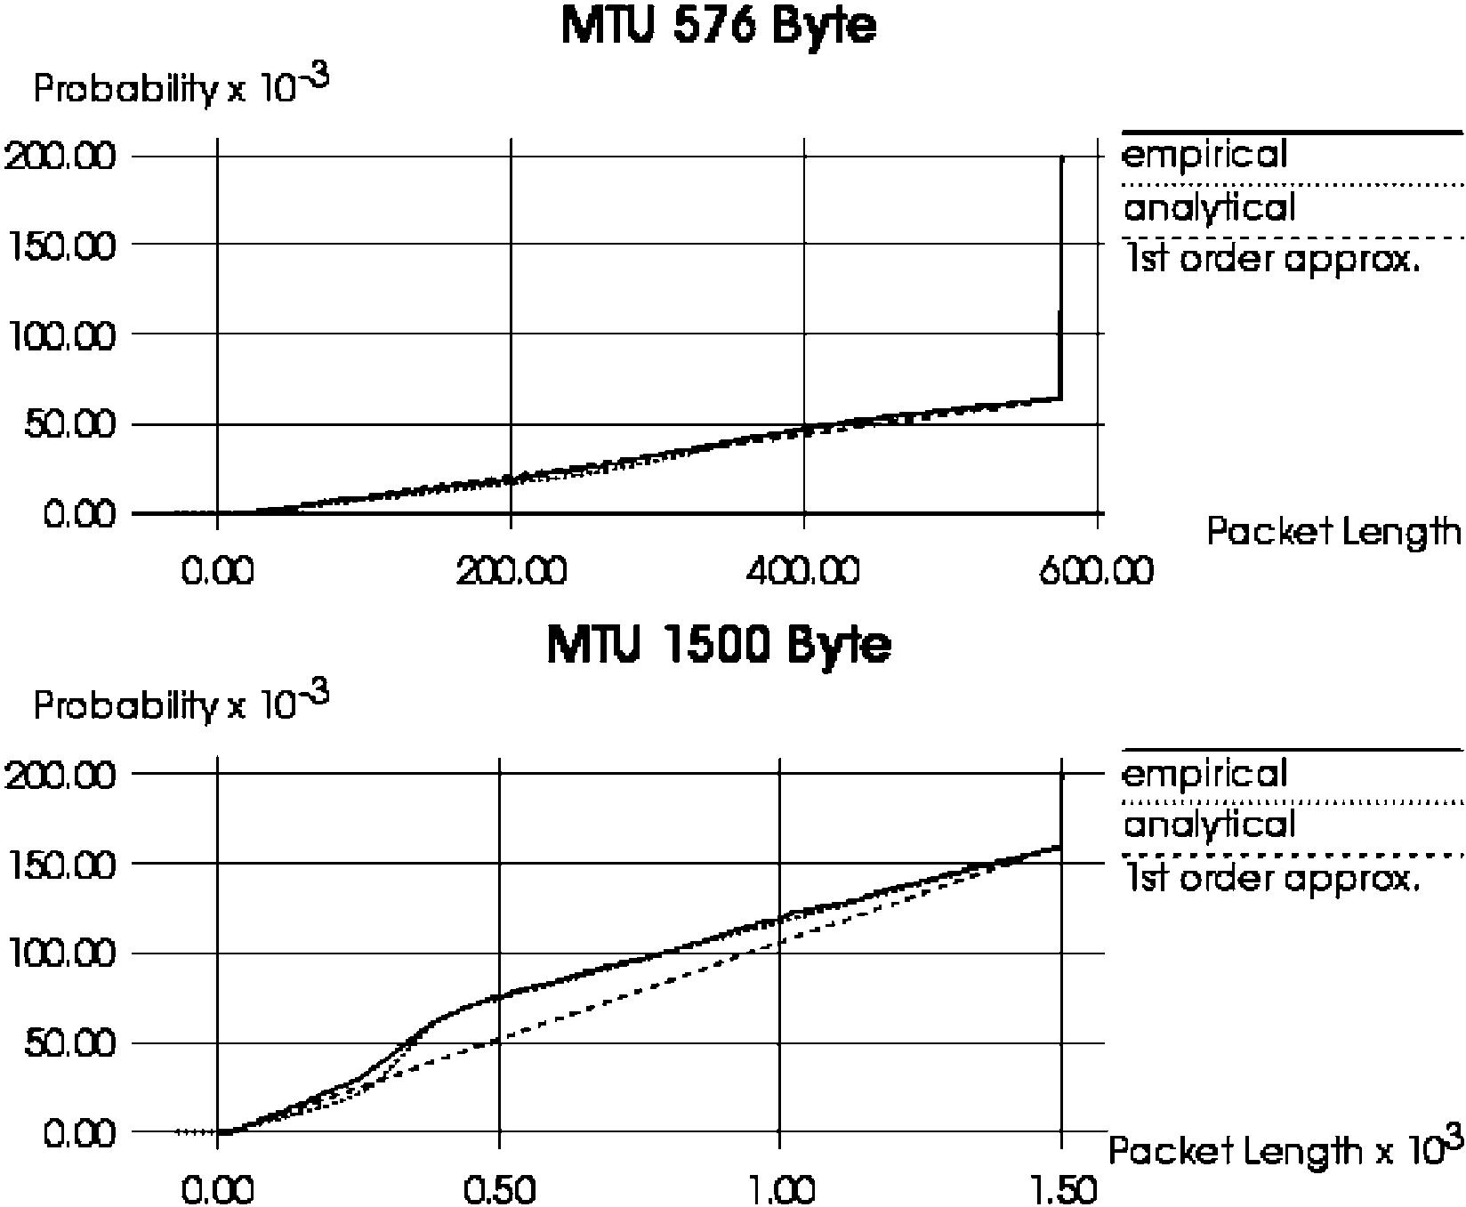
1100

B.E. Wol®nger et al. / Computer Communications 25 (2002) 1094±1102

complex SL is given by a^{p}iªi=b_{i}; where b_{i}are deter-
mined by Eq. (1) for all streams i 1; ј; m: So,Eq. (3)
implies
and found b < 3:0891 (for MTU size of 1500 byte) and b <
7:3922 (for MTU size of 576 byte). Note that b is charac-
terizing the burstiness of load at interface IF_{S}. Comparisons

8

0;

x # c;

I x
>>><>lX1 X
>>:>i 0 j 1

a j^{p}L_{j}x 1 iq 2 n 2 c 2 L_{j}iq 2 n 2 c ; c , x , q 1 c;

4

1;
Eq. (4) now allows us to characterize SL (in terms of distri-
bution of packet lengths) which is induced by a complex PL
representing e.g. the overlay of single video sources in a
video server. For more details regarding the derivation of
our analytical formulae,cf. Refs. [19,20].
Among others,our results would allow us to directly use
and easily parameterize a packet train model [9] (with
deterministic intertrain- and intercar-times) as a realistic
description of the SL to be expected.

6. Validation of our transformer approach in secondary
load characterization bymeans of analytical modeling
We now want to validate the accuracy of our method for
SL prediction based on application of a load transformer. To
prepare the validation we start with measuring both,PL as
generated by single video sources as well as the SL which is
induced by PL and observed at the interface (IF_{S}) between
IP and LLC layer. Measurements have been carried out for
Pentium PCs (166 MHz,under Linux) assuming typical
Internet MTU sizes of 576 and 1500 byte. The sources of
PL active during the measurements have to be modeled to
allow load transformation in the modeling domain. Each
single source is mapped onto a load generator creating a
sequence of requests (video frames to be transmitted) with
a single attribute length based on the measurements of
Section 3. To perform the transformation we just have to
apply Eq. (4) of Section 5 to the given normal distribution.
A x²-test is again used in order to validate the predicted
distribution for SL with respect to the actual,measured
lengths at IF_{S}.
To stress our analytical modeling approach for SL char-
acterization,in the following we will assume a complex PL
resulting from an overlay of m single sources (in particular:
m [ {3; 30}). First,we consider m 3; i.e. a video server
communicating with three video clients. As video sequences
we choose Claire,Foreman and Carphone. The server is
sending sequence Claire on a quantization level of 10
(a^ < 301:52; s^ < 51:34) with a video frame frequency of
12 frames/s,Carphone on a quantization level of 4
(a^ < 3071:75; s^ < 950:58) with 15 frames/s and Foreman
on a quantization level of 1 (a^ < 14; 309:19; s^ < 2424:25)
x $ q 1 c:
between empirical and analytically determined distributions
are presented in Fig. 4.
Besides the excellent conformity between empirical and
analytical distribution it is remarkable that the distribution
function characterizing the pure fragments is nearly linear
for MTU size 576 byte and assuming exact linearity we
can approximate the complete distribution function just by
linear interpolation of { c; 0:0 ; Q; 1=b ; Q; 1:0 }:
The strong non-linearity in the empirical distribution
function (for an MTU size of 1500 byte),cf. Fig. 4,for a
value of the IP packet size of about 300 byte is a conse-
quence of the videosubstream Claire which is part of the PL
and remains completely unfragmented because of the
already very small original video frames,as observed at
IF_{P}. Even in this case,the analytically determined distribu-
tion still predicts highly precise results whereas the ®rst
order approximation leads to small deviations. Neverthe-
less,for practical purposes even the accuracy of the ®rst
order approximation should be acceptable in most cases,
especially as the error in calculating b (according to our
analytical model) is neglectable here again. Results of the
x²-test lead to a value of 1.4767 (with MTU size of 1500
byte) and 0.9763 (with MTU size of 576 byte) for the distri-
bution determined by analytical load transformation. For the
®rst order approximation, x²-test provides values of 9.0654
(MTU size: 1500) and 3.8722 (MTU size: 576). These
values clearly do not argue for rejection of the hypothesis

with 30 frames/s. We calculated b^{P}m_{i}1ªi^{b}i according to
our analytical model for mixed traf®c load transformation
Fig. 4. Comparison between measurement results and analytical modeling
of SL (overlay of three sequences,H.261 encoding).

B.E. Wol®nger et al. / Computer Communications 25 (2002) 1094±1102

1101

that the empirical packet length distribution is adequately
approximated by both distributions suggested (analytical
and ®rst order approximation).
Typically a video server simultaneously serves a large
number of clients. In Ref. [18],we present a detailed
study of a video server operating with an overlay of m
30 sources. The validation leads to results as accurate as the
ones presented here,and moreover,substantiates the
hypothesis that an overlaying of a large number of single
sources intensi®es the effect of linearity in the distribution
function of IP packet lengths up to the MTU size.
As a general conclusion of our numerous validation
experiments,cf. Refs. [19±21],in all comparisons between
the empirical packet length distribution (based on the actual
measurements) and the mathematically predicted length
distribution (based on our analytical load transformation
model) we observed excellent agreement between both
distributions. Predicted SL characterizations were found to
remain valid even when substantially increasing the error
introduced in PL modeling. This results from the fact that,
quite often,already the precise prediction of the expected
number of fragments allows one to produce a suf®ciently
realistic characterization of SL.
Though it might still have been expected that our
approach for analytical load transformation is able to reЇect
the elementary transformations without signi®cant loss of
reality,it is quite surprising,however,that the sequencing of
elementary transformations does not introduce inaccuracies
and that,moreover,one can completely neglect the addi-
tional packets containing just control information,which
may result from processing the offered load within RTP/
UDP and IP layers.
7. Load transformation induced byTCP
The transformation of load as it is executed by the UDP/
IP protocol stack can be modeled much more easily than in
the case of TCP/IP,because TCP behavior is strongly
dependent on the state of the network [8] (e.g. TCP's
congestion control leads to a transformation of the packet
arrival process which is strongly network state dependent,
i.e. there exists some feedback between network and load
generating environment). Thus,in case of TCP,load
modeling can no longer be done by assuming an environ-
ment (comprising the TCP senders),which reacts indepen-
dently of the underlying service provider (comprising the IP
service). So,one could expect that analytical modeling of
load transformation as induced by TCP is completely
unfeasible. However,the situation is much better than
that: luckily,transformation of request attributes (e.g.
packet length) by TCP too,is still largely independent of
the network's state,and therefore,can be modeled as in case
of UDP (cf. modeling of segmentation and header genera-
tion as in Sections 5 and 6). Nevertheless,the problem
remains of how to model the transformation of the packet
arrival process as induced by TCP (i.e. how to model the
transformation of timing behavior by TCP for a sequence of
packets). At present,we see the following methods for
modeling TCP's impact on packet interarrival times:
І One could have some knowledge on how TCP inЇuences
the packet timing during different states of the network
(e.g. network overload versus low network utilization). In
particular,if network utilization is low,analytical model-
ing of TCP's impact on packet timing still seems directly
feasible).
І In case that analytical modeling of TCP's impact on
timing is unfeasible,we still could characterize transfor-
mation of packet timing by TCP based on simulations.
One should note that even if we rely on simulations the
simulation experiments are simpli®ed signi®cantly
because they just have to solve transformation of timing
and not transformation of request attributes (for which
the analytical approach still could be applied).
So,we can conclude that,even in case of TCP,the analy-
tical approach to load transformation is strongly useful. The
present limitations in covering the transformations regard-
ing TCP's impact on packet timing analytically are not
necessarily very serious,in particular,for those situations,
where exact packet interarrival times at the IP interface are
not very relevant. This could be the case in con®gurations,
where we are interested in the packet arrival process at a SL
interface IF₂below IP layer and the arrival process of IP
packets at TCP/IP interface (IF₁) is completely destroyed by
some smoothing or access control process active before the
packets enter at interface IF₂.

8. Summaryand outlook
In this contribution,we have addressed the challenging
problem of real-time workload characterization and modeling
for complex computer networks such as the Internet. Though
quite a few researchers share the opinion that the Internet
cannot be modeled at al ,our view is slightly different. We
agree that the Internet in its totality seems indeed to be much
too complex to be modeled but we claim that adequately
chosen subsystems or special aspects of the Internet can
still be modeled in a suf®ciently realistic manner,at least if
we choose an appropriate level of abstraction.
The focal point of our paper concerns characterization of
SL. For this purpose,we suggested to start with some suf®-
ciently valid characterization of PL and to map the trans-
formation processes,which transform this primary into a
SL,onto some analytical models. This new approach of
investigating load transformation in a modeling domain
seems to be much more Їexible and should lead to more
insight than characterizing SL in the conventional way,
namely,approximating some load measurements collected
in a real network. We were able to show as a result of our

1102

B.E. Wol®nger et al. / Computer Communications 25 (2002) 1094±1102

comprehensive experiments that most of the transformation
processes referring to length attribute are still tractable in a
suf®ciently realistic manner by analytical means.
On one hand,we have demonstrated how to analytically
model load transformations in principle,and on the other
hand,have also applied our modeling approach in compre-
hensive case studies. In order to obtain boundary conditions,
which should be at the same time realistic and relevant from
a practical point of view,we have used Intranet con®gura-
tions as underlying communication networks and video
applications (with standard compression algorithms) as
examples of relevant real-time applications. Not only we
were able to demonstrate a realistic characterization of PL
for video sources,but we also could prove (by comparisons
with real SL measurements) that our method to predict SL
(by using analytical modeling of load transformations) leads
to SL characterizations,which are astonishingly realistic
and thus highly valid.
The realistic load characterization,which is enabled by
our load modeling and load transformation approach,cover-
ing various interfaces within an IP-based protocol hierarchy
can be used in a straightforward manner in combination
with analytical or simulation models as well as a constituent
of an experimental infrastructure for dedicated perfor-
mance measurements regarding subsystems of the Internet.
Limitations of our approach concern,e.g.
І the possibly high expenditure which may result in char-
acterizing the large variety of single sources of PL in the
Internet as well as the mutual dependencies which may
exist between these sources of load;
І the complexity of some load transformation processes
which may not be easily modeled in a suf®ciently
realistic manner,especially if the transformation would
depend strongly on the network's state.
Some of the still open load modeling problems mentioned
may only be very hardly ± if at all ± solvable for the Internet
as a global network in its full complexity. Nevertheless,we
hope that our load modeling approach and,in particular,our
new method for analytical load transformation can and will
be used to derive valid models for innovative communica-
tion networks including real-time oriented subsystems of
the Internet,focusing on RTP and UDP. The application
of such models would allow one to identify and possibly
eliminate (some of the many) bottlenecks in parts of the
Internet,to studyРby means of modelingРthe impact of
changes in the Internet protocol stack (e.g. inclusion of
protocols to support real-time communication or additional
QoS management functionality) and,last not least,to inves-
tigate and predict the behavior of Internet subsystems for
some of the load situations to be expected in the future.
References

[2] M.F. Arlitt,L. Williamson,Internet web servers: workload character-
ization and performance implications,IEEE/ACM Transactions on
Networking 5 (5) (1997).
[3] G. Bai,Load Measurements and Modeling for Distributed Multi-
media Applications in High-Speed Networks,Uni Press,Hoch-
schulschriften,1999.
[4] G. Bai,B.E. Wol®nger,Possibilities and Limitations in Smoothing
MPEG-coded Video Streams: A Measurement based Investigation,
MMB'97,VDE-Verlag,1997 pp. 119±135.
[5] A.B. Downey,D.G. Feitelson,The elusive goal of workload charac-
terization,ACM SIGMETRICS Performance Evaluation Review 26
(4) (1999) 14±29.
[6] R. Epsilon,J. Ke,C. Williamson,Analysis of ISP IP/ATM network
traf®c measurements,Performance Evaluation Review 27 (2) (1999)
15±24.
[7] A. Feldmann,A.C. Gilbert,P. Huang,W. Willinger,Dynamics of IP
traf®c: a study of the role of variability and the impact of control,
ACM SIGCOMM'99 Conference,Computer Communication Review
29 (4) (1999) 301±313.
[8] G. Haring,Chr. Lindemann,M. Reiser (Eds.),Performance
Evaluation: Origins and Directions,LNCS,vol. 1769,Springer,
Berlin,2000.
[9] R. Jain,S.A. Routhier,Packet trainsРmeasurements and a new
model for computer network traf®c,IEEE Journal on Selective
Areas in Communication SAC-4 (6) (1986) 986±995.
[10] J.L. Jerkins,J. Monroe,J.L. Wang,A measurement analysis of inter-
net traf®c over frame relay,Performance Evaluation Review 27 (2)
(1999) 3±14.
[11] J.J. Kim,Formale Lastbeschreibung und eine Methode zur Lastmo-
dellierung fuИr innovative Kommunikationssysteme,Verlag Shaker,
Reihe Informatik,Aachen,1993.
[12] G. Kotsis,K. Krithivasan,S. Raghavan,A workload characterization
methodology for WWW applications,Proceedings of the Inter-
national Conference on the Performance and Management of
Complex Communication Networks,Tsukuba,1997.
[13] A.A. Lazar,G. Paci®ci,D.E. Pendarakis,Modeling video sources for
real-time scheduling,ACM Multimedia Systems 1 (1) (1994) 253±
266.
[14] J. Magott,B.E. Wol®nger,Formal description technique to support
load modelling for innovative communication systems,Applied
Mathematics and Computer Science Journal 4 (4) (1994) 605±633.
[15] V. Paxson,Automated packet trace analysis of TCP implementations,
ACM SIGCOMM'97 Conference,Computer Communication Review
27 (4) (1997) 167±179.
[16] G.D. Stamoulis,M.E. Anagnostu,A.D. Georgantas,Traf®c source
models for ATM networks: a survey,Computer Communications
17 (6) (1994) 428±438.
[17] B.E. Wol®nger,Characterization of mixed traf®c load in service-
integrated networks,Systems Science Journal 25 (2) (1999) 65±86.
[18] B.E. Wol®nger,M. Zaddach,K.-D. Heidtmann,G. Bai,Modeling of
primary and secondary load in the Internet,Technical Report No. 227/
00,Department of Computer Science,Hamburg University,2000.
[19] B.E. Wol®nger,M. Zaddach,K.-D. Heidtmann,G. Bai,Analytical
modeling of primary and secondary load as induced by video applica-
tions using UDP/IP,Proceedings of SPECTS'01,Orlando,Florida,
2001,pp. 276±286.
[20] M. Zaddach,Modellierung,Charakterisierung und Transformation
von Videoverkehrslasten,PhD Thesis,Department of Computer
Science,Hamburg University,2001; published also by: Shaker
Verlag,Aachen,Germany,2001.
[21] M. Zaddach,K.-D. Heidtmann,Measurement and traf®c characteriza-
tion of H.26x-coded video streams,Proceedings of MMB'01,Aachen,
Germany,2001,pp. 89±102.
[22] W. Zhu,Characterizing wide area conversations on the Internet,
MSc Thesis,Department of Computer Science,University of
Saskatchewan,Canada,1994.

